**MACQUARIE UNIVERSITY**

**Macquarie Business School**

--------🙞🙞🕮🙜🙜--------



**BUSA 8000 Techniques in Business Analytics**

**Group 9 Report**

**Authors of Group 9:**

**Task 1 - Khuat Son Tra Nguyen - 48144134**

**Task 2 - Trung Quoc Nguyen -**

**Task 3 - Thi Bich Van Pham -**

**Task 4 - Duc Huy Tran – 48477192**

**Sydney, May 2024**

# INTRODUCTION

Table of contents

INTRODUCTION 1

Chapter 1: Data processing and finding 4

1.1 Data cleaning and wrangling 4

Chapter 2: Data Visualization 5

Chapter 3: Predicting model and future sales 6

Chapter 4: Summarization and Recommendation 7

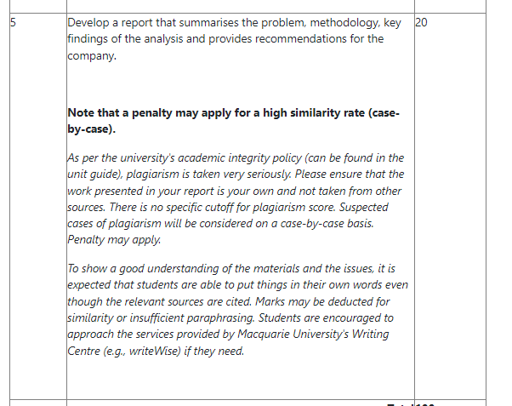

## Chapter 1: Data processing and finding.

## 1.1 Data cleaning and wrangling

## Chapter 2: Data Visualization

## Chapter 3: Predicting model and future sales

## Chapter 4: Summarization and Recommendation